Installing and Setting up PCMaxx

1. Make sure you install as administrator and if you are using Vista or Windows 7 operating systems the user account controls have to be set to off.
2. Install PCMaxx Setup ( use all default settings) say “no to all” when it ask if you want to replace dll’s
3. After PCMAXX is installed copy the highlighted files in the PCMaxxUpdate folder into c:\program files\pcmaxx

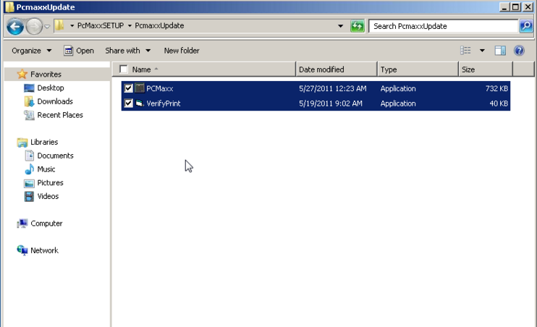

1. After copying and pasting them Dbl click on the verify print file in **c:\program files\pcmaxx** ( nothing will appear to happen but this will register the file)
2. Then register the fplbx.ocx file with regserver32.exe. Go to start type in Run in the search box. Tap Run and enter this line in the command prompt and hit ok regsvr32 "C:\Program Files (x86)\PCMaxx\fplibx.ocx" a box should appear saying that it was successful.

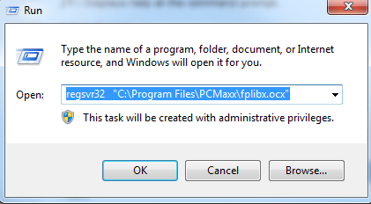

1. IF you are using the finger print readers plug in the finger print reader. In the PcMaxx Setup Folder open the sgdrinstallv65bit32 folder and dbl click on the Setup File 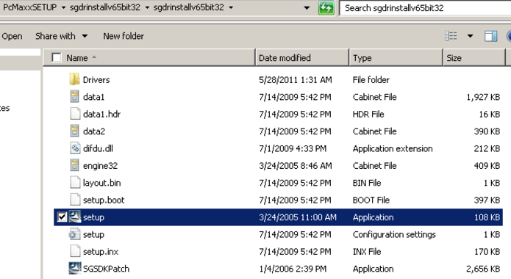
2. Click Next > Next > Finish
3. If you are using the remote syncing capability copy the Folder PCMaxx2webServiceInterface form PCmaxxSetup folder into C:\program files\PCMaxx
4. After copying open C:\program files\PCMaxx\ PCMaxx2webServiceInterface folder and right click on the DataMaxx.Interface.PCMAXX file and send to Desktop Shortcut. Rename the shortcut to PCMaxxSync
5. Dbl click on the short cut to open and click on settings. Add the proper settings and hit Test for both the remote server and your local PC . 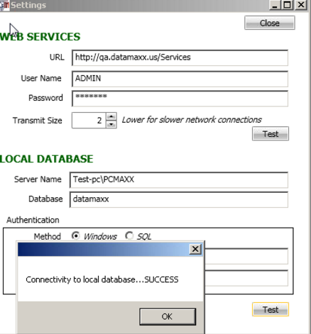
6. Open PCMAXX ( a desktop icon should be made for this as well)
7. Click on Manager UN=admin PW=1234
8. Click on Program Setup
9. Click on Data File and connect to the sql.dmd in C:\program files\PCMaxx 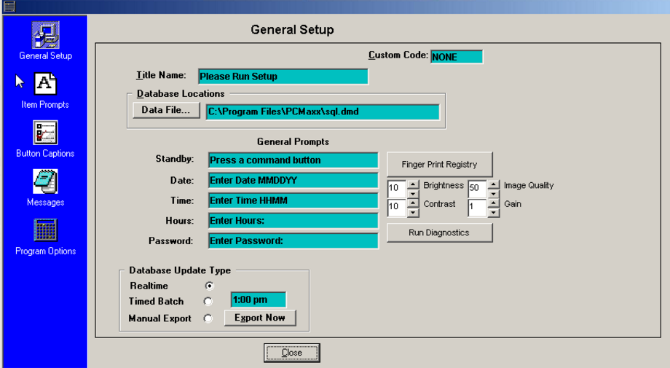
10. Plug in the fingerprint reader to test click on finger print Registry. If the drivers were successfully installed it should look like this. Click the X to exit form . Enter employee ID 1234 and register a fingerprint. 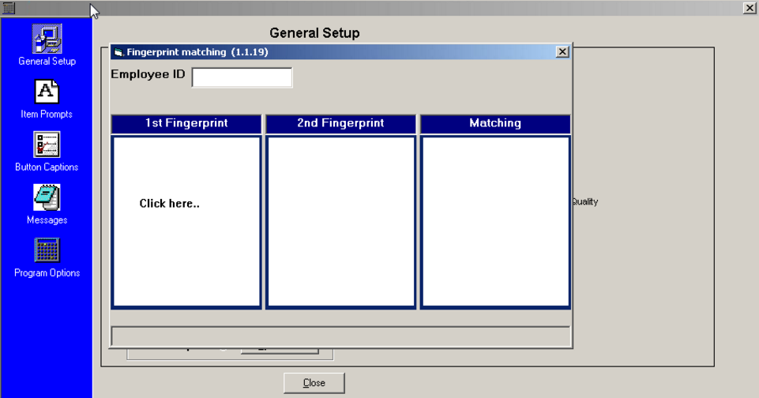
11. Click on Item prompts and check enter Badge ID Enable and use Secugen Fingerprint Validation. 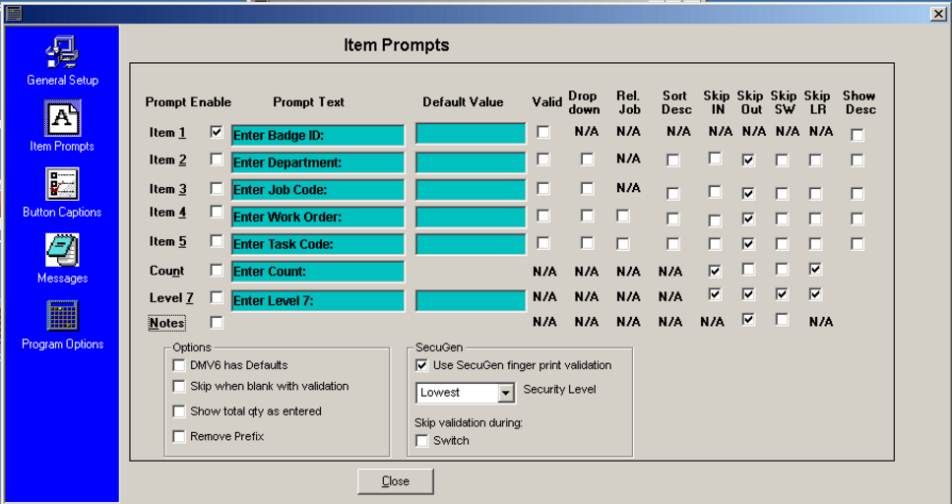
12. Click on Program Options and uncheck Keep Main Window Always on Top and Check Moveable, Minimize, and Sizeable. (the others can be enabled by the customer) 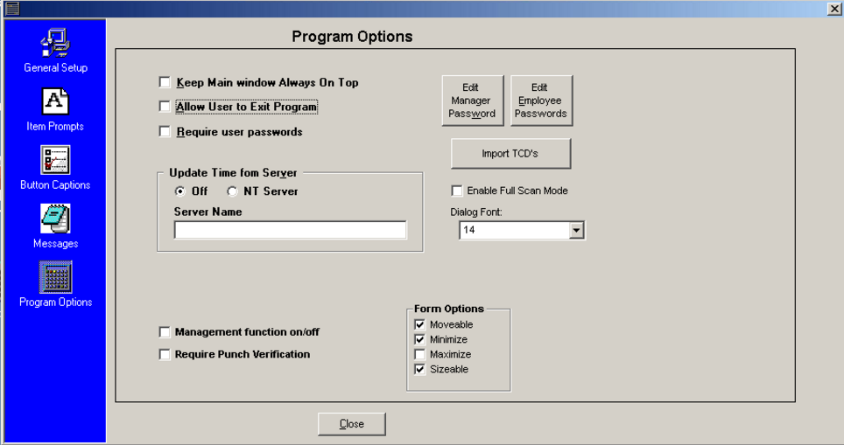
13. Close the Program Setup
14. Exit PCMaxx and Reopen it
15. With the finger print Reader Still plugged in Click start > enter ID 1234> click enter > place finger on the reader. If there are no errors your set up is Complete.